Отчет по ТЗ

1.

Схема бд:

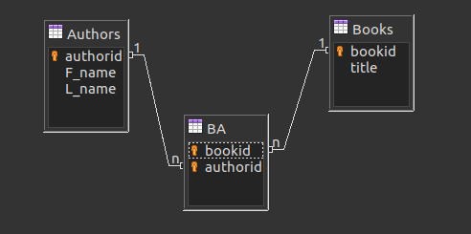

Запрос: SELECT bookid FROM BA GROUP BY bookid HAVING COUNT(authorid)>2;

2.

function brackets_validation($str) {

$tmp = array();

$char_array = str_split($str);

foreach ($char_array as &$value) {

if ( $value == ')' || $value == ']' || $value == '}' ) {

$p = array_pop($tmp);

if ( $p == '(' && $value == ')' ) {

return true;

} else if ( $p == '[' && $value == ']' ) {

return true;

} else if ( $p == '{' && $value == '}' ) {

return true;

}

} else {

array_push($tmp, $value);

}

}

if ( ! empty($tmp)) {

return false;

}

}

3.

function url_replace($str) {

$dom = new DOMDocument;

$dom->loadHTML($str);

$links_a = $dom->getElementsByTagName('a');

$links_img = $dom->getElementsByTagName('img');

$links_script = $dom->getElementsByTagName('script');

foreach($links_a as $link) {

$str = str_replace($link->getAttribute('href'), $link->getAttribute('href') . "?v=" . crc32($link->getAttribute('href')), $str);

}

foreach($links_img as $link) {

$str = str_replace($link->getAttribute('src'), $link->getAttribute('src') . "?v=" . crc32($link->getAttribute('src')), $str);

}

foreach($links_script as $link) {

$str = str_replace($link->getAttribute('src'), $link->getAttribute('src') . "?v=" . crc32($link->getAttribute('src')), $str);

}

return $str;

}

4.

HTML

<!DOCTYPE html>

<html>

<head>

<meta charset="utf-8" />

<title>HTML5</title>

<script src="https://ajax.googleapis.com/ajax/libs/jquery/3.5.1/jquery.min.js"></script>

</head>

<body>

<form>

<input id="a" type="text" placeholder="a">

<input id="b" type="text" placeholder="b">

<input id="c" type="text" placeholder="c">

</form>

Ansver: <span id="ansver">0</span>

<script src="script.js"></script>

</body>

</html>

Java Script

$( document ).ready(function () {

$( "#c" ).change(function() {

var a = document.getElementById('a').value;

var b = document.getElementById('b').value;

var c = document.getElementById('c').value;

var x1, x2;

if(a == 0) {

return document.getElementById("ansver").textContent = "'a' не может быть нулем!";

}

var d = b*b-4*a*c;

if(d > 0) {

x1 = (-b+Math.sqrt(d))/(2*a);

x2 = (-b-Math.sqrt(d))/(2*a);

return document.getElementById("ansver").textContent = "Корни уравнения: х1= " + x1 + ", x2=" + x2 + " Дискриминант: " + d;

} else if(d == 0) {

x1 = -b/(2*a);

return document.getElementById("ansver").textContent = "Корень: х= " + x1 + " Дискриминант: " + d;

} else if(d < 0) return document.getElementById("ansver").textContent = "Корней нет!";

});

});